## NAME: _______________________________________

## Paper Chromatography of Food, Drug, and Cosmetic Dyes Pre-Lab Assignment

Answer the questions below before the start of the lab. They are due to teacher's desk before the start of the lab. Failure to complete these questions before the start of the lab will result in a zero for this experiment. (9 points)

1. What is the mobile phase(s) in this experiment? Is the mobile phase polar or nonpolar? (2 points)
2. What is the stationary phase(s) in this experiment? (1 point)
3. You complete a paper chromatography experiment with three black pens (Pen A, Pen B, and Pen C) using water as the mobile phase. The results you obtain are pictured below. Using a ruler, determine the Retention Factor for spots A, B, and C. (3 points)

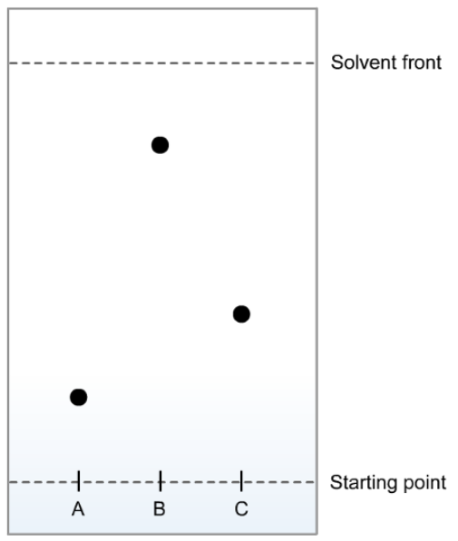

1. Based on your results from Question #3, which pen has the most polar ink? Why? (3 points)